**Assignment Brief – BTEC**

|  |  |  |  |  |  |
| --- | --- | --- | --- | --- | --- |
| **Programme** | | Level 3 Extended Diploma in Creative Media Production (Games Development) | | | |
| **Unit number(s) and title covered** | | Unit 67: 3D Animation | | | |
| **Assignment number & title** | | Assignment One: Understand Theory and Applications of 3D | | | |
| **Student name** | | *Lewis Hawkins* | | | |
| **Assessor** | | David Matravers | **Internal Verifier** | *James Shaun* | |
| **Date issued** | | *17.09.2018* | **Submission deadline** | *27.09.2018 at* ***4.30pm*** | |
| **Assessment Criteria** | **To achieve the criteria, the evidence must show that the student is able to:** | | | | **Assessor confirm met** |
| P1 | Summarise accurately theory and application of 3D with some appropriate use of subject terminology | | | | Y |
| M1 | Explain theory and applications of 3D with reference to detailed illustrative examples and with generally correct use of subject terminology | | | | Y |
| D1 | Comprehensively explain theory and applications of 3D with elucidated examples and consistently using subject terminology correctly. | | | | N |

|  |  |  |  |  |  |  |  |  |  |
| --- | --- | --- | --- | --- | --- | --- | --- | --- | --- |
| **Assessor feedback - 1st submission** | | | | | | | | | |
| *Task No* | *Targeted Criteria* | *Met* | *Comment* | | | | | | |
| 1 | P1 | Y | Lewis, this is a good submission; you have written well about each of the topic areas; some areas are lacking some detail however. You need to fully explain each section and reiterate points with elucidated examples. I am recommending you for the re-work window. Overall a good submission. | | | | | | |
| 1 | M1 | Y |
| 1 | D1 | N |
| **Did the learner meet the original deadline or agreed extension?** | | | | Yes X No ☐ | | | | | |
| **Assessor signature** | | | \\bwstahs1201\stausers\MATRAVERSD\Digital Sig.png | | | | **Date** | | 02.10.2018 |
| **Resubmission authorised?** | | | | Yes X No ☐ | | | | | |
| **New agreed deadline date for submission** *\* must be within 10 days of receiving original assignment back* | | | | 26.10.2018 | | | | | |
| **Lead Internal Verifier signature** | | |  | | | **Date** | |  | |
| **Assessor feedback - Resubmission** | | | | | | | | | |
|  | | | | | | | | | |
| **Assessor signature** (resubmission only) | | |  | | **Date** | | | |  |

|  |  |  |  |  |
| --- | --- | --- | --- | --- |
| **Scenario** | | | | |
| You have been approached by an up and coming independent 3D modelling company “3D Modellers “R” Us” but they know little or nothing about the theory and applications of 3D.  You have been assigned the task to produce a document comprehensively explaining what the different theories and applications of 3D are and how they can be used within the creative media industry. | | | | |
| **Tasks and criteria covered** | | | | |
| **Task 1**  Within this task you have to comprehensively explain the following topic headings with elucidated examples. Your explanations should be detailed and cover the full range of the below points, your use of examples should be used to support the points you make in order to demonstrate your understanding of 3D Applications.  •**Applications of 3D** – e.g. models, product design, animations, TV, film, web, games, education, architectural, walk-through  •**Displaying 3D Polygon Animations** – application programme interface, graphics pipeline, rendering techniques, rendering engines, distributed rendering techniques, lighting, textures, fogging, shadowing, vertex and pixel shaders, level of detail  •**Geometric Theory** – vertices, lines, curves, edge, polygons, element, face, primitives, meshes (wireframe), coordinate geometry (two dimensional, three dimensional), surfaces  •**Mesh Construction** – box modelling, extrusion modelling, using common primitives (cubes, spheres, pyramids etc.)  •**3D Development Software** – software (3Ds Max, Maya, AutoCAD, Cinema 4D etc.), file formats (.3ds, .mb, .C4d, .obj), plug-ins  •**Constraints** – polygon count, file size, rendering time  You should take the time to ensure you cover all the bold headings within this task to demonstrate an appropriate range of understanding. Included alongside the bold headings are examples of some of features you may want to include in your document, but you do not have to cover all included examples after the bold headings. | | | | |
| **Evidence you must produce for this task** | | | | |
| Fully completed portfolio with all bold headings written about. | | | | |
| **Sources of information** | | | | |
| **Textbooks**  Baylis P, Freedman A, Procter N et al – BTEC Level 3 National Creative Media Production, Student Book  (Pearson, 2010) ISBN 978-1846906725  Baylis P, Freedman A, Procter N et al – BTEC Level 3 National Creative Media Production, Teaching Resource  Pack (Pearson, 2010) ISBN 978-1846907371  Ahearn L – 3D Game Textures: Create Professional Game Art Using Photoshop (Focal Press, 2006)  ISBN 978-0240807683  Birm J – Digital Lighting and Rendering (New Riders, 2006) ISBN 978-0321316318  Brooker D – Essential CG Lighting Techniques with 3Ds Max (Focal Press, 2008) ISBN 978-0240521176  Capizzi T – Inspired 3D Modelling and Texture Mapping (Premier Press, 2002) ISBN 978-1931841504  Gahan A – 3ds Max Modelling for Games: Insider’s Guide to Game Character, Vehicle, and Environment  Modelling (Focal Press, 2008) ISBN 978-0240810614  Summers D – Texturing: Concepts and Techniques (Charles River Media, 2004) ISBN 978-1584503002  **Journals**  3D World  Develop Magazine  Edge Magazine  MCV Magazine  **Websites**  www.3dcafe.com – texture and model resources  www.blinkimage.com – use of environment walk-throughs etc  www.turbosquid.com – textures, models and 3D tutorials | | | | |
| **Student checklist** | | | | **Complete?** |
| Proofread work | | | |  |
| Reference / Bibliography (if applicable) | | | |  |
| All pages attached and numbered – including introduction/conclusion/front sheet | | | |  |
| **Authenticity of Evidence Student declaration** | | | | |
| I certify that the evidence submitted for this assignment is my own.  I have clearly referenced any sources used in the work.  I understand that false declaration of authenticity (i.e. plagiarised work) is a form of academic misconduct and the relevant College procedures will be instigated if I am found to be in contravention of these. | | | | |
| **Student signature** | digital signiture | **Date of submission** | 27.09.2018 | |
| **Re-authentication of Evidence Student declaration (for resubmission only)** | | | | |
| **Student signature** |  | **Date of resubmission** |  | |

NB. Students – the assignment starts on the first page **after** these front sheets, i.e. Page 1.

* For your convenience, page numbers have been inserted into the footer. **Please keep them**.
* You may choose to add a contents table (ToC) in this section.
* Please **do** **not use text boxes** for the main body of your written answers.
* Please make sure that images/screenshots are correctly formatted, laid out and labelled. A table of Figures (ToF) may also be added if you wish.
* Make sure you use Page (or Section) Breaks whenever a new page is required. (Rather than adding large numbers of Return/Paragraph characters.) Ensure that new Section breaks continue with correct orientation and correct page numbers.
* Ensure that you have referenced your work throughout, using references in text and that you also have a reference list and full bibliography at the end of the work according to the current **Harvard Referencing** conventions. **Failure to do so will make your work more difficult to authenticate.**

**Task 1:**

**Applications of 3D:** In this section I will explain how 3D models are used in the industry. The applications of 3D include toys, product design, film, games, education, and architectural.

The 3D models can be created in 3D modelling software such as 3DS Max, and used in video games, film, education, and much more.

**Video Games:**

It’s used in video games to create characters, environments, items and usable objects. In games the quality of the models is much lower than in the other applications. This is because in games and animation the computer must render the 3D objects vertex by vertex. In most game engines the polygons are converted to tris(Triangles) which are composed out of 3 verities only.

To optimise performance objects can be culled when facing away or at a distance which allows for the models to be of a higher quality, this is called occlusion culling. View frustum culling is similar, but instead culls polygons.

In videogames such as Call of Duty, 3D models are used to create the guns characters environments etc. The game has a high focus on characters and guns, so the quality of the models are higher than the environments.

**Movies:**

Movies are very similar exempt for the models used for movies are extremely detailed, because in games the models are being rendered by the engine, however, in movies such as toy story (image below) the models are already rendered and recorded as a video. This means it can run smoothly regardless how many polygons are in an object. There are constraints though, if the models are too high quality rendering could take an extremely long time (hours or days for a frame). For a short film this might not be much of a problem, but when the movie is hours long, 60 FPS, this can be a problem.

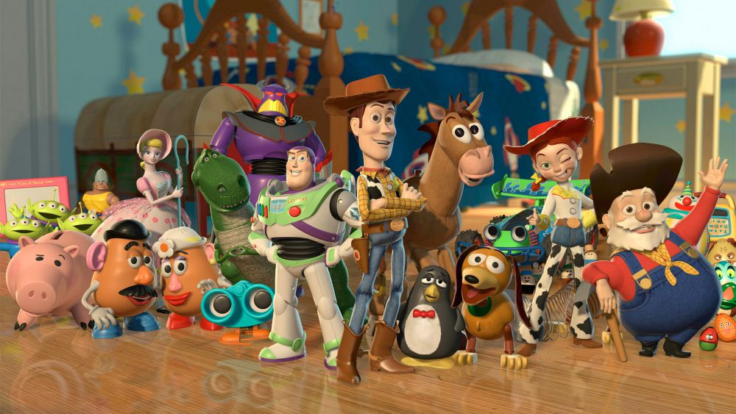

https://www.google.co.uk/search?q=toy+story+2&rlz=1C1CHBF_en-GBGB761GB761&source=lnms&tbm=isch&sa=X&ved=0ahUKEwisna3e7ZPYAhVFB8AKHVlBC1IQ_AUICygC&biw=1366&bih=613#imgrc=2a8C7beZ57yKZM:

**Product Design**

3D modelling can be used to create toys. It’s used because the model is simpler to create and only has to be made once before production. In This application the 3D model can be as high poly as the computer will handle, since it’s only used as a reference.

3D modelling is used to create an accurate model for reference. For example, if a company wanted to create a new chair, the design could be created in 3D modelling software before creating a physical prototype. This method of creating prototypes is favoured by company’s because its quicker and cheaper, meaning multiple models can be created in the time it would take to create one out of physical materials.

**Architectural**

3D modelling is used in architecture to create prototypes of buildings and structures. This method is extremely cheap compared to creating the building, and more efficient than drawing it, as its 3D. When the 3D object is created a program can be used to place it on a 3D map of the area in which you want it to be on. This means the building designer can see the object as if it were actually there.

**Education**

In education 3D modelling is used to help students learn all the above.

**Application programme interface (API):**

Application programme interface (API) is a set of routines, protocols, and tools used to build software. API specifies how software components should interact. It’s used for communication between various software components and provides the building blocks needed to create a computer programme. An example of API is Windows API (Image below). Windows API is the core of Microsoft’s operating systems.

https://www.google.co.uk/search?q=windows+api&rlz=1C1CHBF_en-GBGB761GB761&source=lnms&tbm=isch&sa=X&ved=0ahUKEwjr9_rG-ZPYAhXlLMAKHdgIAjwQ_AUICygC&biw=1366&bih=662#imgrc=g71_PXZcU_XYKM:



Graphics pipeline is the process of rendering the scene. It renders it piece by piece as shown in the graph below. This is a method of rendering used in both 2D and 3D. It’s also mainly used for Realtime rendering.

https://msdn.microsoft.com/dynimg/IC412590.png

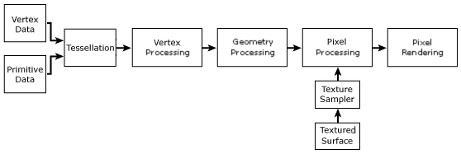

**Rendering Techniques and Engines.**

One form of rendering is radiosity which defuses light in reflections and makes shadows softer for a more realistic look. Radiosity solves the equations for scenes with surfaces which reflect light. It mainly just dims shadows passing through transparent materials but can also be used to reflect light of surfaces.

A rendering engine is a piece of software which draws text and images on the screen. Examples of rendering engines are Scanline, Mental Ray, and Vray. Different render engines render in different ways creating different levels of quality. Where one might excel in reflections, another might in refraction.

The Unity game engine has many ways of rendering from real-time to baked. The game engine much like others (Unreal, CryEngine) has many options to customise lighting, shadows, reflections, and refractions.

With the most recent large update Unity received, the Light-weight Render Pipeline(LRP) and the High Definition Render Pipeline(HDRP) were introduced, finally giving developers the opportunity to choose between powerful graphics for high-end computers and current generation consoles (HDRP), and lower-end computers and mobile (LRP).

When changing shadow settings, the developer can change the samples (Higher = better quality), how dark the shadows are, and whether they’re baked, real-time, or mixed.

The type of game the developer’s creating depends on the settings they picked. For example, if the game is on mobile there would have to be sacrifices with the graphics to increase render time, since the platforms are unable to complete large tasks (Like the PS4 can) yet.

Turning down sample rates, shadow quality, baking instead of real-time, and switching to the light-weight render pipeline, would be a must do.

Below is an example of two lightmap renders. One of Progressive(Left) and Enlighten(Right).

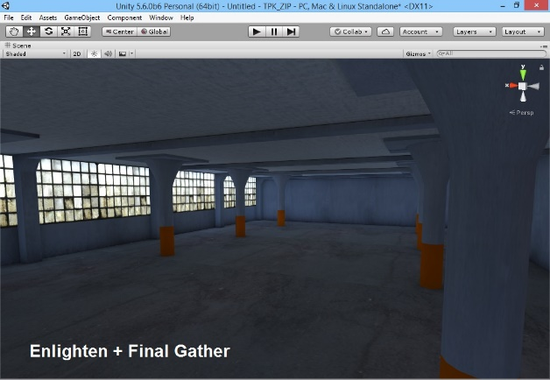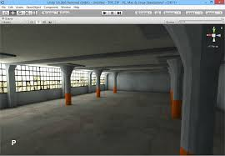

**Textures, Fogging and Shadowing:**

Textures, fogging and shadowing,are all (exempt for fogging) ways of reducing the file size of a game. Textures are 2D objects on the mesh which are composed of pixels, the higher the resolution (number of pixels) the bigger the file size. Fogging is not a way of reducing the file size, but a way of hiding the results of culling. It can also be used to scare the player in a horror game instead, or as an added feature. Shadowing can increase the game size. To reduce this, developers either remove shadows for certain light emitters or reduce the strength of the shadow.

**Geometric Theory:** In this section I will explaining how the 3D models are constructed. The geometric theory includes vertices, polygons, face, primitives, meshes (wireframe), coordinate geometry (two dimensional, three dimensional), and surfaces.

A vertex is each angular point of a polygon, a polygon is a 3D shape, a face is the flat side of a polygon, and the primitives are a collection of vertices, edges and faces to define the shape of a simple, 3D object. A mesh is the collections of vertices, edges and faces of a polygon, 2D is flat using only X, and Y axis. And 3D is an object in 3-dimensional form, using the X, Y, and Z axis.

All 3D games use a form of 3D modelling and in most of game engines triangulate (Turns all polygons into triangles) the mesh. Triangulating the mesh makes the model easier to render and avoids strange issues while generating or manipulating meshes during runtime. However, often they do allow for this to be disabled, such as in Unity which allows the developer to disable this feature in the import settings of the model.

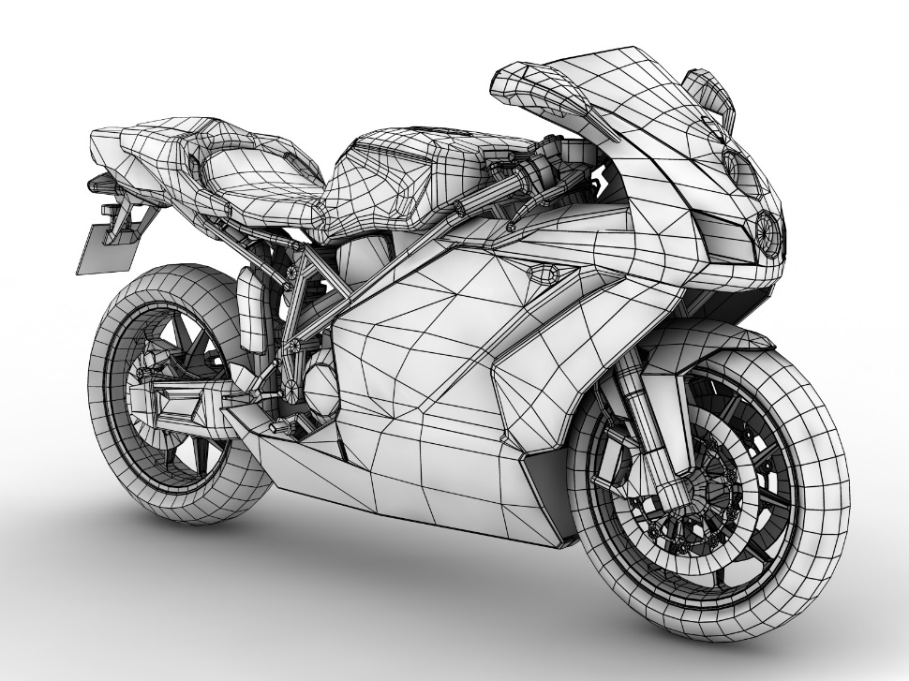

The model above could be used in a video game as its low-poly. To achieve this the geometry of the model is organised to produce the best effect when smoothed because it needs to render in real time.

**Mesh Construction:** In this section I will explain how models are constructed. The mesh construction includes extrusion modelling, and using common primitives (cubes, spheres, pyramids etc.).

Faces are defined through the number of vertices it uses. 3 = Tris (Triangles), 4 = Quad (Squares), 5+ = N-Gons.

Extrusion is When an objects face is extended, this is used to make the object bigger. On its own its not than useful, yet when paired with another form of mesh construction such as insect it can be used to create more complex shapes.

Another form of mesh construction is insect, this is used to create another face within a face allowing for the face to be extruded while still having a flat surface around it.

Bevel is a mix of both extrusion and insect. It extends the face but also makes it bigger or smaller. It’s also used to smooth hard edges.

Bridge is used to connect two or more edges through adding a face.

Merge is used to join 2 or more vertices. It can be used to repair mesh.

In games the models are created to be “Low-Poly”, This means they have fewer polygons and most of the details are added through normal and albedo UV maps. To maximise the quality of the model without changing the polygon count the modeller uses topology. Topology is the organisation of polygons which when organised in a specific way can make areas look better when smoothed.

God of War (2018) is a good example of this because it uses this method to make it almost impossible to see the polygons. This is displayed in the image below.

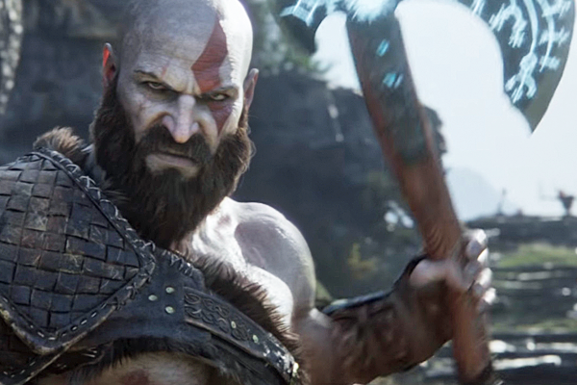

**3D Development Software:** In this section I will explain how different types of 3D software can be used to create a model. The 3D development software includes software (3Ds Max, Maya, AutoCAD, Cinema 4D etc.), file formats (.3ds, .C4d, .obj), and plug-ins.

**File Formats:** The file format .3ds is a file which holds 3DS Max objects with their animations. .C4d is a 3D model created with Cinema 4D. It contains a scene, which consists of one or more objects with position, rotation, pivot points, meshes, and animation information. Finally .obj is used for the storage of 3D objects only.

3Ds max is used to turn a common primitive into a more complex shape like a person or a gun, MudBox is used for sculpting, and adding small details, along with shading, and Maya is used for animating and rigging a model.

.fbx is the best for games because it contains the model, animation, and the UV data. However, Unity can convert most of the softwares basic files (.3ds, .ma, and. blend) into. fbx making these an equally good option.

All are needed to create a character. 3DS Max is used to make the basic structure from a common primitive. However, you can rig and animate a model in 3DS Max.

MudBox is used to sculpt the basic model and add facial features, such as ears and eyes.

Maya is used for rigging and animating the competed model.

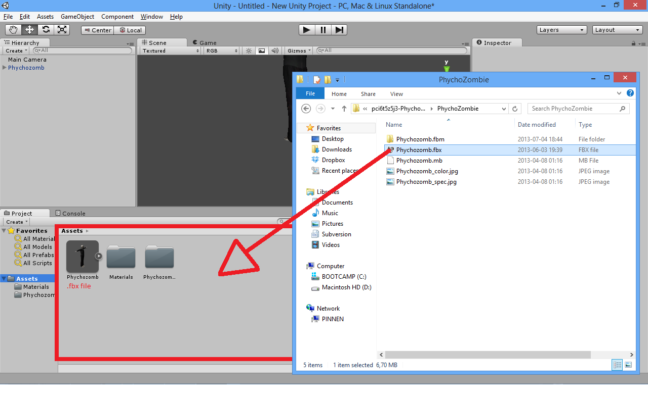

**Constraints:** In this section I will explain how specific techniques can improve the render time of an object. The constraints include polygon count, file size, and rendering time.

The polygon count increases both file size and render-time as there are more faces. Render-time affects FPS (Frames per Second), as it must render the faces in every frame. During cut scenes this can be avoided if the cut scene is not acted out by the in-game characters such as that in Grand Theft Auto V, but a short pre-made video playing in the game like the cut scenes in Destiny 2. In Grand Theft Auto V the cut scenes are acted out in real time so there is no enhanced graphics, as seen in the image below. However, in destiny 2 the models used can be drastically increased as the cutscene is just a 2D, premade, video being played in the game, therefor the polygon count doesn’t affect the FPS, or the resolution.

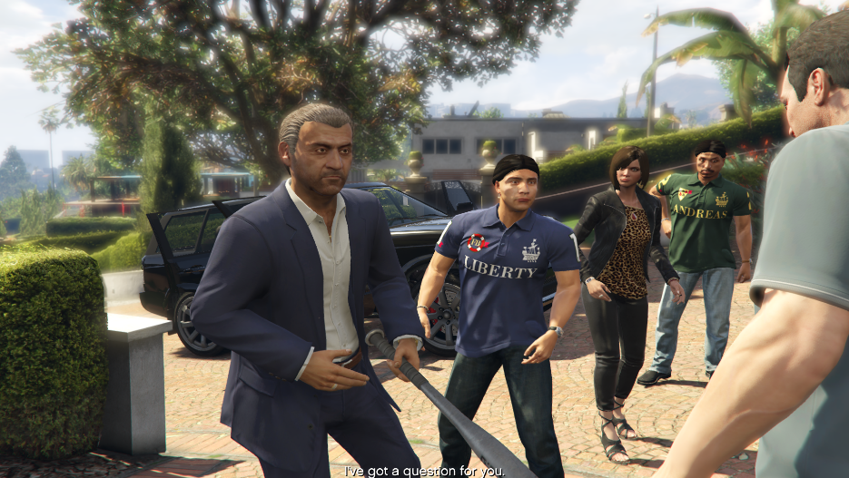

https://www.google.co.uk/search?q=GTAV+cut+scenes&rlz=1C1GGRV_enGB770&tbm=isch&source=lnms&sa=X&ved=0ahUKEwiPkbaW4rPXAhXP6aQKHfSUB64Q_AUICygC&biw=1280&bih=958&dpr=1#imgrc=NmcrZZo1hH4CSM: